Git & IntelliJ Assignment

1. Git add command allows us to stage the individual files or all files in the directory at once, adding them to the staging area(index) in preparation of commit.
   * + git add . --- adds all changes in the current directory
     + git add index.html --- adds a html file(single file)
2. git branch feature-group
3. A pull request is a way to request the changes that are made in one branch(feature) be merged into another(main branch).
   * + Push branch to GitHub
     + Go to the repo on GitHub
     + Click “Compare & pull request”
     + Add description/title and click “create pull request”
4. Go to git repo -> settings ->collaborators -> Add people -> Search by username, full name, or email -> Add to repository
5. git commit –m “Commit Message”
6. Create a guthub account at <https://github.com> and create a repository name rg-assignments by clicking on create repository.
7. git branch feature-java

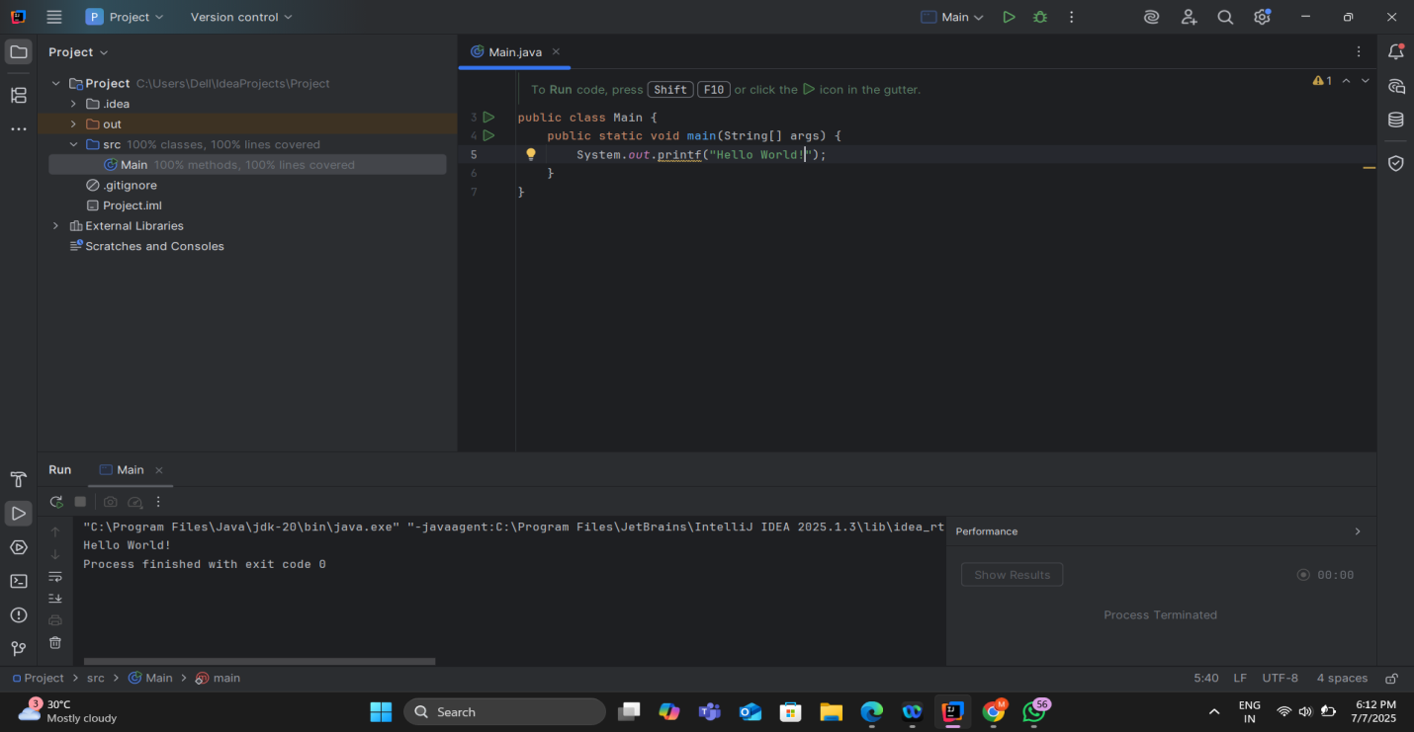

9. To run the project: Shift + F10

To select a line: Shift + End

To comment/uncomment a line: Ctrl + /

To delete a line: Ctrl + Y